List of labs
- Installation of Kubernetes 1-Master and 2-Nodes Cluster
- Choose a Network Solution and Configure
- Deploying Applications as a Pod
- Managing Labels & Selector
- Deploying Replica on Controller & Replica Set
- Creating & Managing Service
- Deploying Applications as Daemon Sets
- Using Manual Scheduling or Taints and Tolerations
- Deploying Applications as Deployment
- Using Node Affinity to Deploy Pods

Lab Details
  - This lab walks you through the steps to install the Kubernetes cluster.
  - You will use terminal.

Introduction

What is Kubernetes?
Kubernetes is a container orchestration tool majorly used to control and manage container-based environments.
Kubernetes works on a master-slave node setup where one central node will control the underlying worker nodes.
Here we are using kubeadm for the installation of the kubernetes cluster and in the current lab, the cluster is a 1- master node and 2 worker node cluster.
Kubernetes is required to manage and control container-based applications as it streamlines the process of performing container operations even in a large-scale environment.
We require container images to run the container and all the container-related commands can be run using the command line utility kubectl. Kubectl utility provides an abstraction over the underlying container engine. This means, that whatever the container runtime is, the operations commands would be the same. It is applicable for the runtimes which are part of the CRI-O initiative.
With Kubernetes, we can implement various deployment strategies and plan the release timeframes and in most cases, without any downtime. Also, it is a cost-effective solution as containers require minimal resources and environment based on that would cut out the overhead costs.

Pre-requisites:
Basic Linux Commands

Task Details
- Launching Lab Environment.
- Using terminal
- Install Kubernetes.

Lab Steps:

Lab Steps

Task 1: Launching Lab Environment
- Launch the lab environment opening Master machine.
- Open the terminal.

Task 2: Mappings of hostnames to IP addresses
- Run the below command on master machine to configure a local DNS resolver that maps hostnames to IP addresses.
vim /etc/hosts
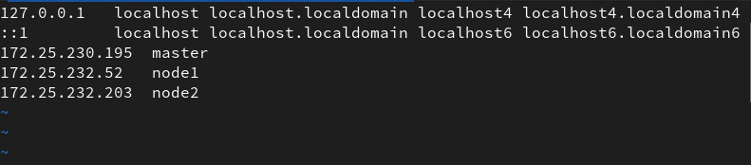
- Now, we will use scp to copy the /etc/hosts file from master to worker node.

scp /etc/hosts root@<node1-IP>:/etc/hosts scp /etc/hosts root@<node2-IP>:/etc/hosts
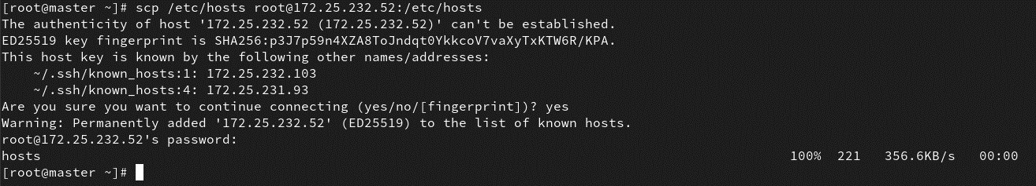

Task 3: Packages on the system
- In this step, we will run the YUM package manager to update all installed packages on all the machines. The -y flag automatically confirms all prompts, allowing the update process to proceed without user intervention.

yum update -y

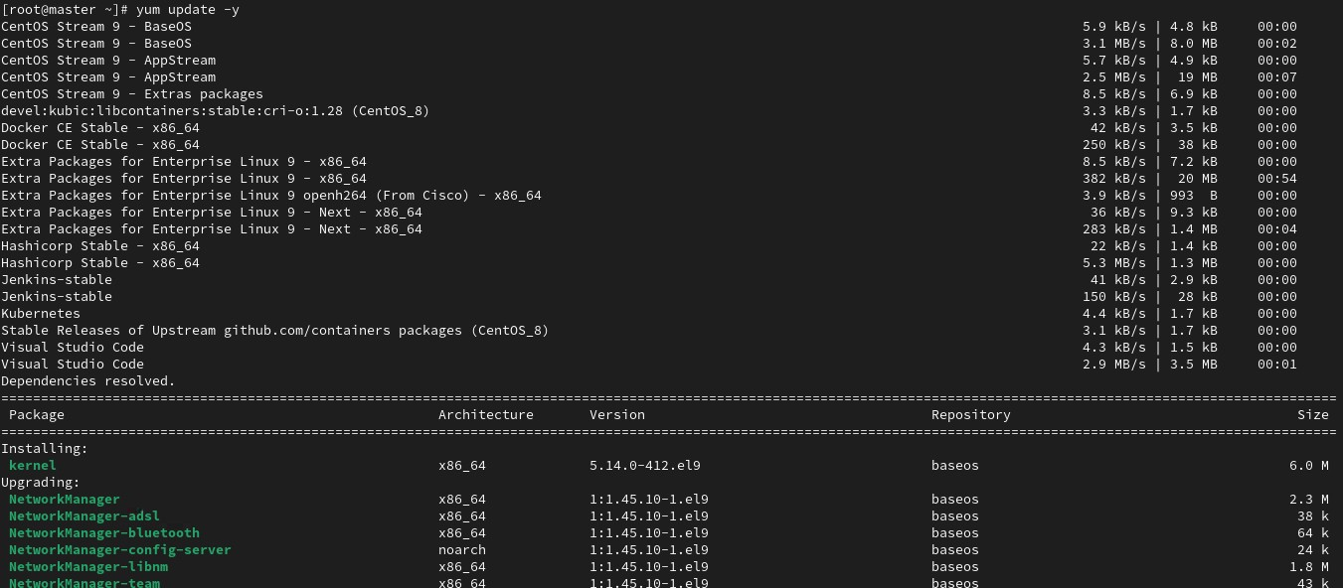

- This command installs the specified packages (crio, kubectl, kubeadm, and kubelet) using the YUM package manager. The -y flag automatically confirms the installation of packages without requiring user confirmation.(on all machines)

yum install crio kubectl kubeadm kubelet -y

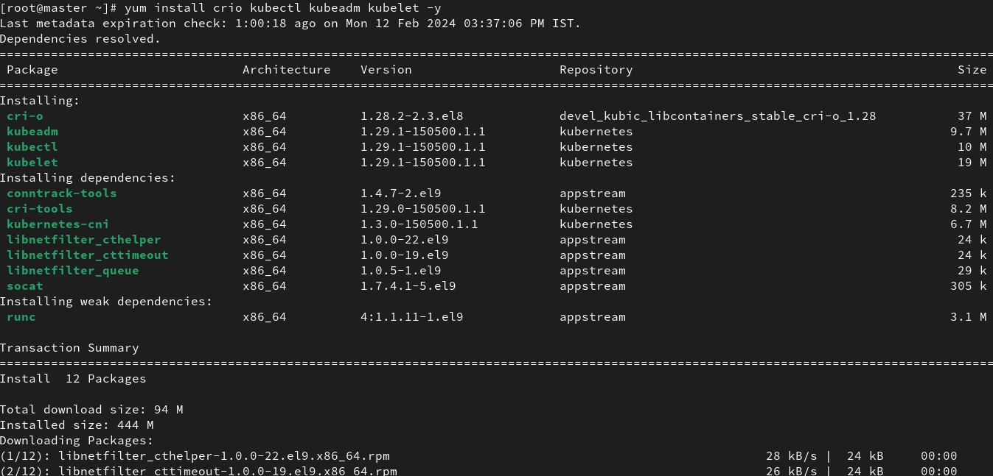

- Now let's start and enable kubelet and crio services. (all machines)

systemctl enable –-now crio kubelet
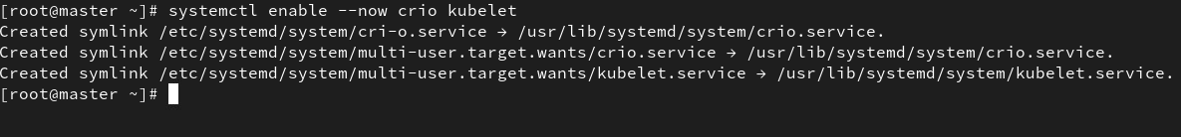

Task 4 : Initialize the cluster
- We will run this command which initializes a Kubernetes control-plane node. The -- pod-network-cidr=10.244.0.0/16 flag specifies the range of IP addresses to assign to pods in the cluster. (master only)

kubeadm init --pod-network-cidr=10.244.0.0/16
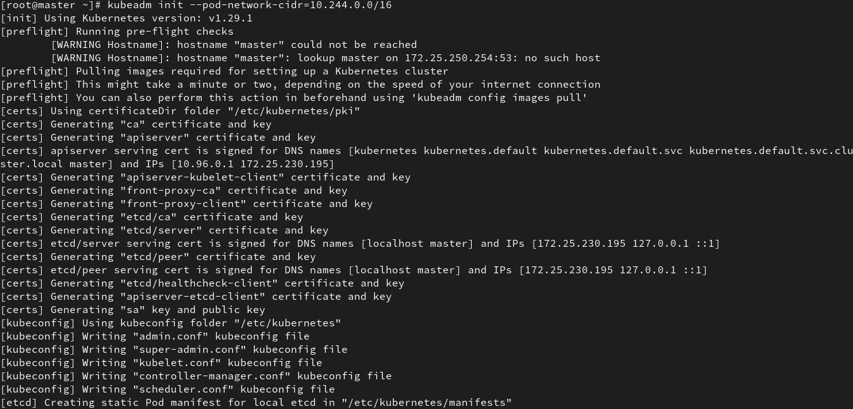
- This command creates a directory named .kube in the user's home directory if it doesn't already exist. This directory is typically used to store Kubernetes configuration files. (master only)

mkdir -p $HOME/.kube

- This command copies the Kubernetes cluster configuration file (admin.conf) to the .kube directory in the user's home directory, naming it config. (master only)

cp -i /etc/kubernetes/admin.conf $HOME/.kube/config

- This command changes the ownership of the copied Kubernetes configuration file to match the user's ownership, ensuring that the user has the necessary permissions to access the cluster configuration. (master only)

cp -i /etc/kubernetes/admin.conf $HOME/.kube/config

- Now, to join the worker nodes to the cluster you can run the command printed in master machines. (on worker nodes only)
kubeadm join 172.25.230.195:6443 --token rb1j.v7ugj --discovery-token-ca-cert-hash sha256:6c56e

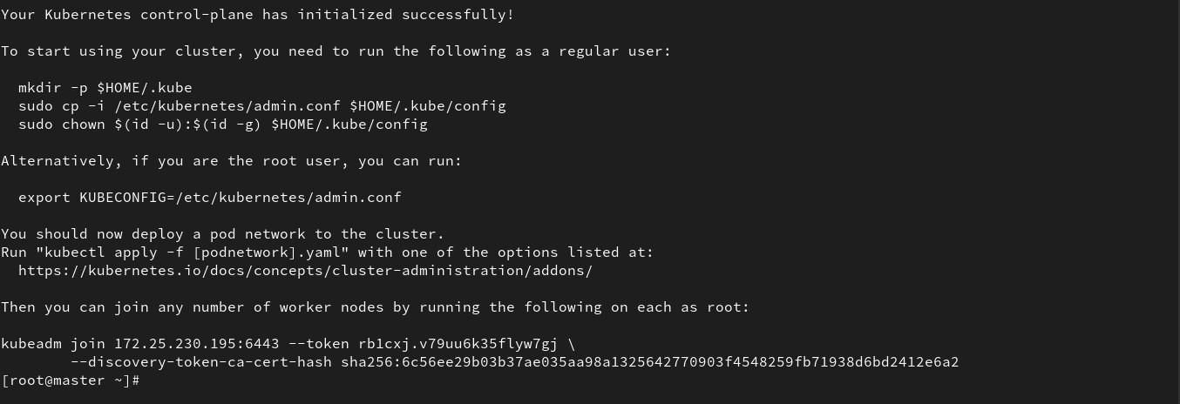

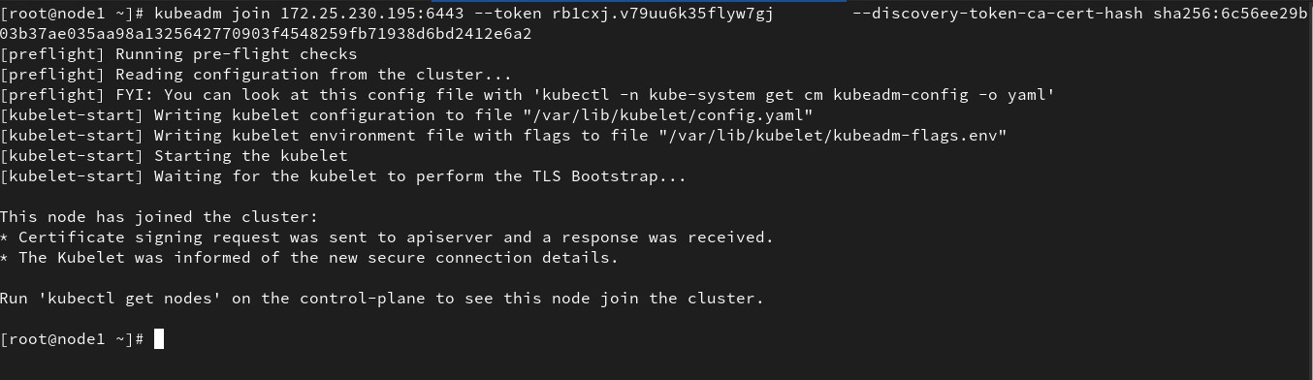

Completion and Conclusion
- You have successfully installed packages required.
- You have successfully initiated K8s cluster.

End Lab
1. You have successfully completed the lab.

Lab Details
- This lab walks you through the steps to Network Solution on and Configure in the Kubernetes cluster.
- You will use terminal.

Introduction

What is CNI?
Container Network Interface (CNI):
Container Network Interface (CNI) is a standardized interface between container runtimes and network plugins. It enables configuring networking for containers by allowing container runtimes like Docker, Kubernetes, and others to call plugins to handle networking functionality. CNI plugins are responsible for tasks such as assigning IP addresses, setting up network namespaces, and creating network interfaces for containers.
Calico:
Calico is an open-source networking and network security solution designed for Kubernetes and other containerized environments. It provides highly scalable networking capabilities for connecting containers, virtual machines, and bare-metal workloads. Here's an explanation of Calico in key points:
Network Policy Enforcement: Calico provides robust network policy enforcement capabilities, allowing administrators to define fine-grained network policies based on labels, selectors, and IP addresses. These policies enable segmentation and isolation of network traffic, enhancing security within the cluster.
Integration with Kubernetes: Calico seamlessly integrates with Kubernetes, leveraging its network policy API to enforce security policies and manage network resources. It operates as a CNI plugin, allowing Kubernetes to leverage Calico's advanced networking features.

Pre-requisites:
Basic Linux Commands

Task Details
- Launching Lab Environment.
- Using terminal
- Install calico as network solution.
- Validation Test

Lab Steps:

Lab Steps

Task 1: Launching Lab Environment
- Launch the lab environment opening Master machine.
- Open the terminal.

Task 2: Verify the cluster configuration
- Run the below command to check the version of `kubectl` package. Kubectl allows us to control the cluster via a command-line interface. One can run the kubectl commands followed by the resource arguments to send API requests to the master node and run the intended task over the worker node.
kubectl version
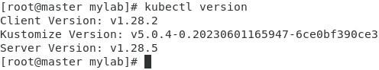

- Now, verify the kubelet service is running by the following command. Kubelet service pods are running on both the master and worker nodes and this service is responsible for sending and receiving API requests within the cluster.
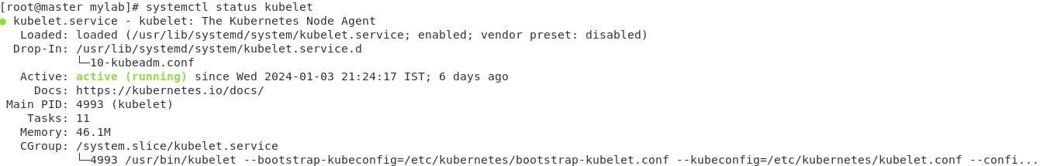
systemctl status kubelet

Task 3: Install Calico as network solution and configure
- In this step, we will download the Calico YAML manifest file from the specified URL. The manifest file contains the definitions of the various Kubernetes resources required to deploy Calico, such as pods, services, and configuration..

curl https://raw.githubusercontent.com/projectcalico/calico/v3.27.0/manifests/calico.yaml -O

- This command opens the calico.yaml file in the Gedit text editor. Gedit is a simple text editor commonly used in Linux distributions with graphical user interfaces.

gedit calico.yaml
The user need to find and replace feature in the text editor to replace occurrences of "docker.io" with "quay.io" in the calico.yaml file. After making the replacements, the user should save the file.

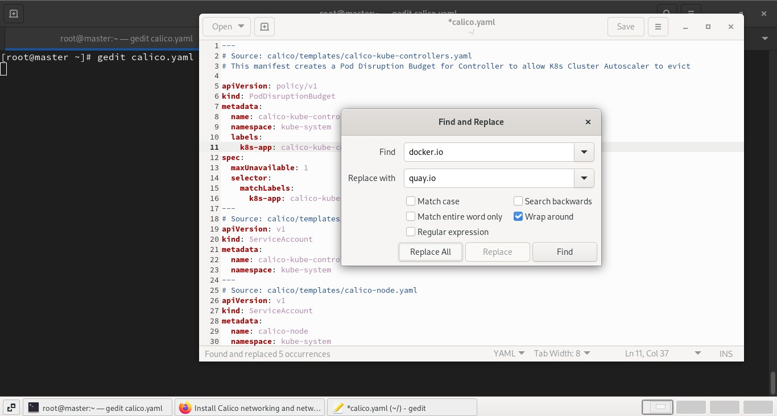

- Now let's deploy Calico components such as pods, services, and configuration

kubectl apply -f calico.yaml

Task 4: Validation Test

1. Last step is to verify all the prerequisite pods are up and running. These pods are the helping hand in performing cluster operations like scheduling, network policy and route management, API request handling, proxy service and so on. Run the following command to fetch the pods running in all the namespaces.

kubectl get pods --all-namespaces
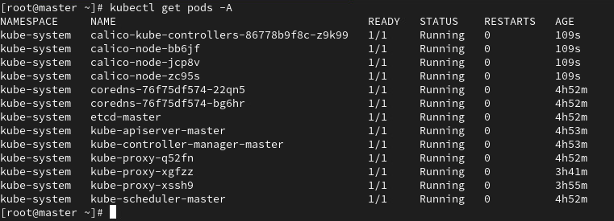

Make sure all pods display status RUNNING which implies all the required pods are upand running

Completion and Conclusion
- You have successfully downloaded and modified calico yaml.
- You have successfully deployed calico into K8s cluster.

End Lab
1. You have successfully completed the lab.

Lab Details
- This lab walks you through the steps to launch and configure a web server deployment in the Kubernetes cluster.
- You will use terminal.

Introduction

What is Kubernetes?
Kubernetes is a container orchestration tool majorly used to control and manage container-based environments.
The smallest unit in a Kubernetes cluster is a pod. Containers run inside the pods. In some use cases, a single pod can also contain multiple containers. By using Kubernetes operators, we communicate to the pods and further, the pods communicate with the underlying containers to perform the tasks. The actual application always runs on the container but the pod is the abstraction unit from which we can interact with the containers.
Kubernetes is required to manage and control container-based applications as it streamlines the process of performing container operations even in a large-scale environment.
In this lab, we will create a pod that will include a container serving the Apache web server inside it.
We require container images to run the container and all the container-related commands can be run using the command line utility kubectl. Kubectl utility provides an abstraction over the underlying container engine. This means, that whatever the container runtime is, the operations commands would be the same. It is applicable for the runtimes which are part of the CRI-O initiative.
With Kubernetes, we can implement various deployment strategies and plan the release timeframes and in most cases, without any downtime. Also, it is a cost-effective solution as containers require minimal resources and environment based on that would cut out the overhead costs.

Pre-requisites:
Basic Linux Commands

Task Details
- Launching Lab Environment.
- Using terminal
- Install an Apache Server
- Create a Pod with Apache server
- Create and publish the page
- Validation Test

Lab Steps:

Lab Steps

Task 1: Launching Lab Environment
- Launch the lab environment opening Master machine.
- Open the terminal.

Task 2: Verify the cluster configuration
- Run the below command to check the version of `kubectl` package. Kubectl allows us to control the cluster via a command-line interface. One can run the kubectl commands followed by the resource arguments to send API requests to the master node and run the intended task over the worker node.
kubectl version
- Now, verify the kubelet service is running by the following command. Kubelet service pods are running on both the master and worker nodes and this service is responsible for sending and receiving API requests within the cluster.

systemctl status kubelet

- Last step is to verify all the prerequisite pods are up and running. These pods are the helping hand in performing cluster operations like scheduling, network policy and route management, API request handling, proxy service and so on. Run the following command to fetch the pods running in all the namespaces.

kubectl get pods --all-namespaces

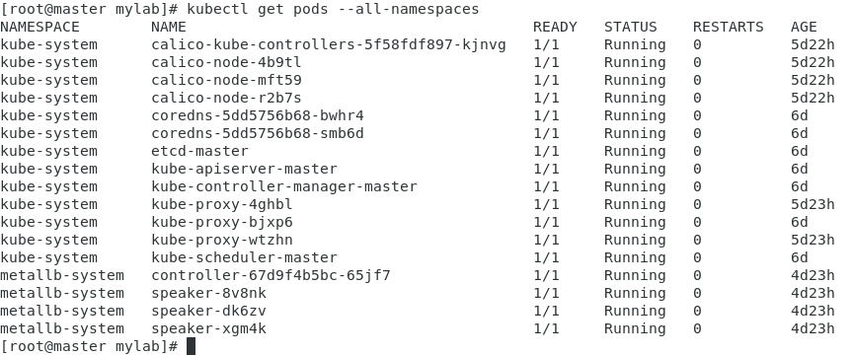
Make sure all pods display status RUNNING which implies all the required pods are up and running and we can perform the further steps.

Task 3: Create a Pod with apache server
- In this step, we will launch a pod running the Apache web server inside a container. We will use the official container image of the web server which is httpd. Run the following command to deploy a pod with httpd container image.

kubectl run server --image=httpd

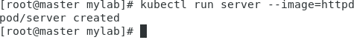
- Verify the pod is running or not by the following command. Initially, the node will

download the container image from the image registry and hence it will take a few seconds to spin up the container. The following command will stream the phases in which the pod gets deployed.

kubectl get pods

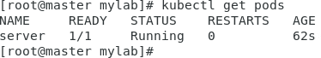
- Observe the behind the scene process and terminate the command after the pod status is running. Press ctrl+c to terminate the command execution.
- Now let's go inside the container and configure web page on top of the container image downloaded from the registry

kubectl exec server -it -- bash

- You will see a change in the user and directory of the current terminal which implies that we are now inside the container.

Task 4 : Create and publish the page
- First, navigate to the document root folder of the web server. The document root is the directory from which the content is being served. This simply means that whatever web pages are available inside this folder location, will be served to the end user.

cd /usr/local/apache2/htdocs

- To add the contents into the index.html file using echo, copy and paste the below command to the shell of the container.

echo "<html>Hi, We are testing web server</html>" > index.html

- Now, exit the container and return to the base Terminal

exit

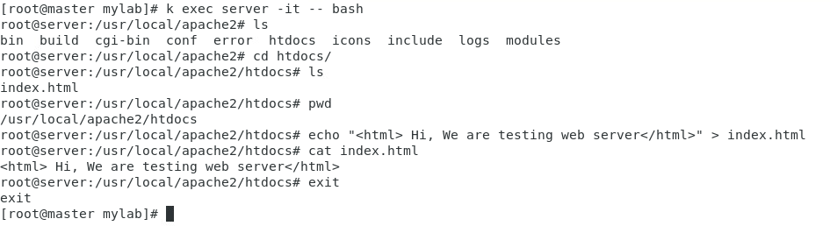

Till here, we have launched and configured a pod and Apache web server is running inside it. And we configured a sample index page and pasted the same into the document root of the server.

Task 5: Validation Test
- Let’s fetch the IP address of the container by the following command:

kubectl describe pods server | grep IP

- We will now put a curl request within the terminal to check whether the container is hosting the webserver or not

curl <ip-of-container>/index.html

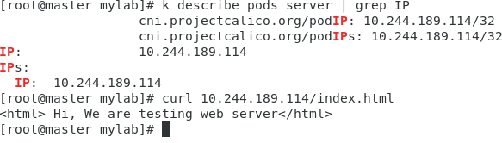
- You will see the content from the index.html file on the command line which indicates that the webserver is successfully hosted on a container. The server is only accessible locally as we have not configured the networking and routing for the pod.

Completion and Conclusion
- You have successfully verified Kubernetes cluster components.
- You have successfully deployed a sample web server pod inside K8s cluster.
- You have successfully created a webpage and published it backed by a container

image named httpd.

End Lab
- You have successfully completed the lab.
- Once you have completed the steps, delete the resources.

Lab Details:
- This Lab Walks You Through Understanding Labels and Selectors in Kubernetes

- Cluster Configuration: 1 Master And 1 Worker Node

What are Labels and Selectors?
In Kubernetes (K8s), labels and selectors are key concepts used to organize and manage resources within the cluster. They are metadata attributes attached to K8s objects that enable grouping, filtering, and selection of resources based on specific criteria. This helps in organizing and managing resources more effectively.

Labels:
- Labels are key-value pairs attached to K8s objects (such as pods, services, nodes, etc.) to provide additional metadata.

- Labels are used for identifying and categorizing resources based on different characteristics, such as environment (e.g., production, development), role (e.g., frontend, backend), version, etc.

Selectors:
- Selectors are used to filter and select resources based on their labels. They allow you to define criteria for identifying a set of resources.

- Selectors are essential for operations like deploying applications to specific environments, grouping resources for scaling, and defining access policies.

Lab Tasks:
- Define Kubernetes Pod

- List and Retrieve the Pod

Launching Lab Environment:
- Launch The Lab Environment By opening the Master machine.

- Open the terminal.

Lab Steps:

Define Kubernetes Pod:
In this step, we will create the manifest file that defines a Kubernetes Pod configuration. We are going to create two pods in this step one with environment as production and the other one with production environment.

Create manifest file using YAML approach
- Create a YAML file using the command below:
vim labelpod.yml

- Now pass the below sample yml code. This will attempt to create the specified Pod based on the provided details. Once done press CTRL+X and the Y and Enter to exit the terminal.
apiVersion: v1 kind: Pod metadata:
name: pod-demo labels:
environment: production app: nginx
spec:
containers:
- name: nginx
image: quay.io/gauravkumar9130/nginx

- The next step is to apply this yml file to create the deployment as declared.
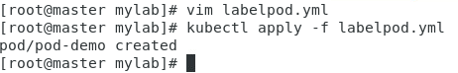
kubectl apply -f labelpod.yml

- Now let's create the other pod with development environment. To do so make use of the following command:
nano labelpod2.yml

- Paste the following yaml manifest in the editor and save and return.
apiVersion: v1 kind: Pod metadata:
name: pod-demo2
labels:
environment: development app: nginx
spec:
containers:
- name: nginx
image: quay.io/gauravkumar9130/nginx

- Now apply the yml file to the deployment.
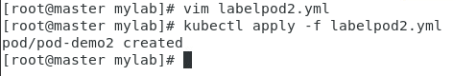
kubectl apply -f whiz2.yml

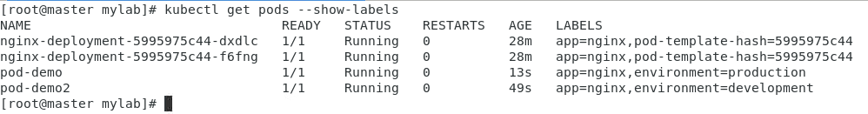
- Now, let's list both the created pods with the help of the following command to ensure successful creation:
kubectl get pods --show-labels

List and Retrieve the Pod:
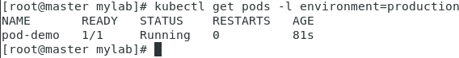
In this step, we will list pods based on label selectors. In our case, we are retrieving pods that have labels environment=production. The command would be:
kubectl get pods -l environment=production

End Lab:
- You Have Successfully Completed The Lab.

- Once You Have Completed The Steps, delete the resources.

Lab Details
- This lab walks you through the steps to understand and configure replication controller resources in the Kubernetes.
- You will practice using the terminal.

Introduction

What is Replication?
Replication in Kubernetes is an important resource that maintains identical copies of the pod. It is responsible for managing the lifecycle of the pods. Containerized applications generally have a large number of containers and managing the lifecycle of those pods manually isn't a good option as containers are volatile.
The replication concept ensures the uptime of the pods required at one point in time. The administrator defines the ideal number of pods supposed to be running while declaring the configuration and the replication service keeps track of the mentioned number. Replication service works in maintaining the desired state for the application.
So, if some pods crash or fail, replication takes note of this and launches child replicas having the same environment to ensure the application doesn't observe downtime due to the unavailability of the service.
Replication is a concept and there are 2 services responsible for governing replication.
ReplicaSet Replication Controller

What is Replication Controller?
As we already know replication takes care of the desired state in containerized applications. ReplicationContoller ensures a specified number of pods are up and running for a given point in time. This program keeps track of the underlying pods with the labels attached to them and matches the number of running pods with the desired number of pods.
This program always keeps on monitoring the underlying pods and maintains the exact number of replicas. The use of ReplicationController is to run an identical number of pods and ensure uptime.
The short abbreviation of ReplicationController is "RC" which is widely used in the command line.
RC works with the label selector concept. More specifically, equality-based selectors. We will see this concept in detail in the later half.

Task Details
- Launching Lab Environment.
- Using terminal
- Create the YML declarative file for RC
- Describe the resource
- Delete the replication controller

Lab Steps

Task 1: Launching Lab Environment
- Launch the lab environment by opening Master machine.
- Open the terminal.

Task 2: Create RC using YAML approach

We can create RC resources using both the command line and the YAML approach. But, as the application grows, it is recommended practice to go with the YAML approach to maintain all the application configurations in a declarative manner.
The keyword replicas in the YAML file are referred to as the desired number of pods and add labels to the resource so that the program can monitor and take care of the uptime. labels are linked with the pods and used to keep track of the replication program.

Using YAML approach
- Create a YAML file using the command below:
vim replication_controller.yml

- Now pass the below sample yml code. Here, apiVersion is v1 which means this resource is included and maintained under the mentioned version of the Kubernetes API. Also, the keyword kind suggests the type of the resource which is ReplicationController in this scenario.

apiVersion: v1
kind: ReplicationController metadata:
name: nginx spec:
replicas: 2
selector:
app: nginx
template:
metadata:
name: nginx
labels:
app: nginx
spec:
containers:
- name: nginx
image: quay.io/gauravkumar9130/nginx

- The next step is to apply this yml file to create the RC as declared.

kubectl apply -f replication_controller.yml

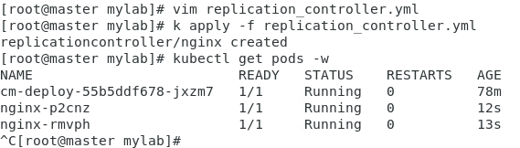
With this command, we can successfully create the RC from the yml file created above. Verify the same by running the kubectl get pods command. It may take a few minutes first time as the nginx container images are being pulled from the registry.

Task 3: Describe the replication controller
- As we launched the ReplicationController in the previous step, let's now perform a describe operation to get the detailed data about the replication controller resource.

kubectl describe rc/nginx

- Run the above command to get a detailed description of the launched resource. From the whole output, "pod status" and "replicas" are important as they tell the desired state pod status and the actual desired state. From these two fields, we can determine whether the controller is working or not.
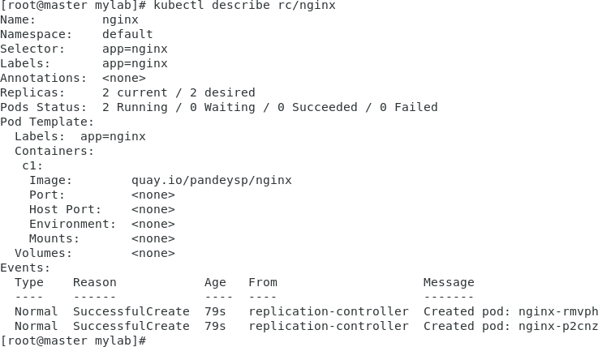

Task 4: How to delete RC?
1. Delete RC including the pods
This will delete the RC resource and all underlying pods by scaling down them to 0. It is suggested to take a backup before performing this as it will delete the replication controller as well as all the running pods including the temporary data.
kubectl delete rc nginx

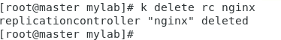
Completion and Conclusion
- You have successfully created a replication controller resource in the Kubernetes.
- You have successfully described the created resources and observed the detailed information of the created RC
- You have deleted the configured RC.

End Lab
- You have successfully completed the lab.
- Once you have completed the steps, delete the resources.

Lab Details
- This lab walks you through the steps to conﬁgure ReplicaSet resources using the kubectl command-line utility.
- You will use terminal and create a sample declarative ﬁle to launch the pod with the desired state conﬁguration.

Introduction

What is ReplicaSet?
Replicaset works on the concept of replication. The primary responsibility of ReplicaSet is to maintain the desired number of pods up and running at one point in time. It is often used to guarantee that speciﬁed pods are available at all times. This program monitors underlying pods with speciﬁc label and keeps track of the uptime of those pods.
It works on the label selector method. But ReplicaSet uses a "set-based" selector which provides more customization than ReplicationController. The query method of the labels provides wider options which makes this service widely used nowadays instead of ReplicationController.
The short form of ReplicaSet is "rs". We mostly use the abbreviated term in the command line.
It creates new pods with the same labels and templates if the desired state is not matched and destroys extra pods if running pods are more than the desired state.

Task Details
- Launching Lab Environment.
- Using terminal
- Create the YML declarative ﬁle for RS
- Describe the resource
- Delete the ReplicaSet

Lab Steps:

Lab Steps

Task 1: Launching Lab Environment
- Launch the lab environment by opening Master machine.
- Open the terminal.

Task 2: Conﬁgure ReplicaSet
We can use the command-line and YAML approach to create ReplicaSet and both approaches give the same results. However, the YAML approach is more used and recommended as the declarative approach gives more ﬂexibility and we can maintain the whole conﬁguration of the resource in a single ﬁle and maintain versioning which can be helpful at the time of rollback to previous versions.
The main attributes in the replica set are labels because the whole program works to match the labels on the underlying resources. Take note of the kind and labels keywords in the declarative ﬁle below. Here, we've attached multiple tags to the pods based on the environment and provide a unique identity to the resource.

ReplicaSet using YAML approach:
- Create a declarative YAML ﬁle using the below command.

vim replica_set.yml
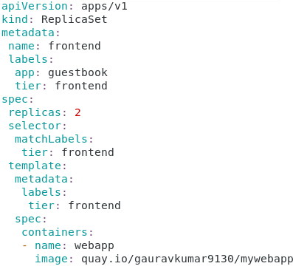

- Now paste the YAML ﬁle below in the editor. The pod label as a speciﬁcation to
indicate the rs to watch the pods matching the set-based rule and maintain uptime for the same. For creating the YAML code, kind would be "ReplicaSet" and apiVersion would be "apps/v1" that indicates ``rs`` has been released in a later part than RC

apiVersion: apps/v1 kind: ReplicaSet metadata:
name: frontend
labels:
app: guestbook
tier:frontend spec:
replicas: 2
selector:
matchLabels:
tier: frontend
template:
metadata:
labels:
tier: frontend
spec:
containers:
- name: webapp
image: quay.io/gauravkumar9130/mywebapp
- Having this ﬁle completed, run the below command to apply and create the ReplicaSet as mentioned:

kubectl apply -f replica_set.yml

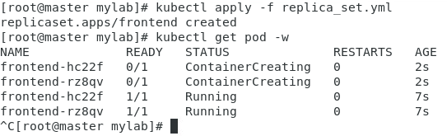
So, this is one of the ways to create an independent ReplicaSet and ensure the uptime for the application pods. The watch command will stream the whole container deployment process and we can see the desired number of pods up and running after a few seconds. First- time execution may take a little more time as the container images are being pulled from the hub..

Task 3: Describe the ReplicaSet:
The task of creating the ReplicaSet is done. Now is the time to fetch the details about it and understand it in a better format. Use the describe command to get all the details about ``rs``.
kubectl describes replicaset/frontend
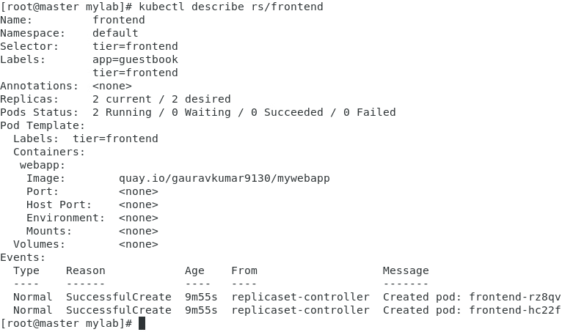

In ReplicaSet, pod status and desired number of pods are the key outputs to watch out for. From these details, we can get a whole idea about the process. Also, the events section in the bottom states all the details about the pod and throws the error in case of deployment failure. With the describe command, we can see the actual running pods and desired number of pods and take needful actions if there is some fault.
Bare pods are not a recommended practice if you're thinking of an environment at scale. Pods being watched by a program like ``rs`` gives assurance of minimal downtime.

Task 4: Delete the resources

We learned how to create and describe rs resources and now we'll see how to delete the created rs using the command line.

1. Delete the whole ReplicaSet:
This approach is used when we want to destroy the rs environment completely. Here, the rs and underlying pods will be deleted and further uptime won't be maintained as the watching program rs is not on the head. It is recommended to take backup of the container data before running this command as it will erase the whole temporary data.

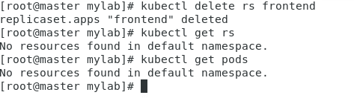
kubectl delete replicaset frontend

Completion and Conclusion
- You have successfully created a ReplicaSet resource.
- You have successfully described and deleted the created resources through it.

End Lab
- You have successfully completed the lab.
- Once you have completed the steps, delete the resources.

Lab Details
- This lab walks you through the steps to understand and configure service networking with Cluster IP type.
- You will use the terminal.

Introduction

What is Cluster IP service?
As we already know about service networking in Kubernetes, Cluster IP is yet another type of defining networking rules within the cluster.
This service allows us to expose the pods internally for particular addresses and the mentioned resources will be only accessible inside the cluster.
By default, any provisioned resource will have this policy applied and the resources are accessible within the clutter by default.
Using this service, we can restrict access to some applications from external access and only allow other services within the cluster.
For example, in a multi-tier application, rather than exposing the backend or database pods to the public endpoint, we only access the frontend to the external access and for inter-connection of database and backend, we implement Cluster IP service.
Also, with this service, we can allow inter-communication for a specific static IP address defined in the manifest file.

Task Details
- Launching Lab Environment.
- Using the terminal
- Create the YML declarative file for the sample application.
- Verify the service using Kubectl command
- Delete the service

Lab Steps:

Lab Steps

Task 1: Launching Lab Environment
- Launch the lab environment opening Master machine.
- Open the terminal.

Task 2: Create the YML declarative file for the application
In this step, we will create the manifest file for a sample nginx application and we will launch multiple replicas for the same. Then, we will create a cluster IP service and verify the endpoints of the replicas are included in the service

Create a manifest file using YAML approach
- Create a YAML file using the command below

vim ecom.yml

- Now pass the below sample yml code. Here, we are only creating replica set of the web application.
apiVersion: apps/v1 kind: ReplicaSet metadata:
name: ecom spec:
replicas: 3
selector:
matchLabels:
app: ecommerce
template:
metadata:
labels:
app: ecommerce
spec:
containers:
- name: c1
image: quay.io/gauravkumar9130/mywebapp
- The next step is to apply this yml file to create the resource as declared.

kubectl apply -f ecom.yml

- Afterward, by running the kubectl get pods -o wide command, we can verify the nginx pods are up and running with 3 identical replicas.

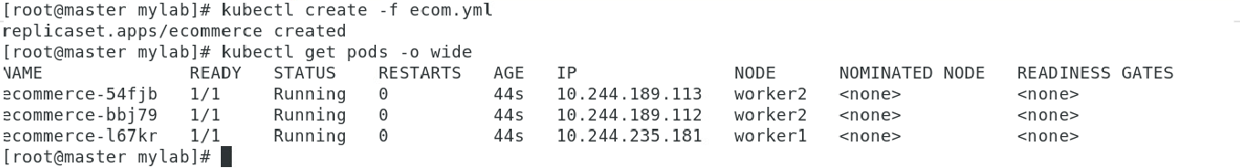
- Now, let’s define the YAML file for the Cluster IP service where we will use the mapped port number to expose within the cluster. Create a new file with the command below:

vim clusterip.yml

- Now paste the following code in the file and save the same.
Here, we have used the label selector method to match the labels for the application pods and corresponding replicas to perform network communication and load balancing. The kind Service refers to the networking resource in the Kubernetes. Also, we are using TCP protocol for this particular service. The argument of mentioning protocol is optional.
apiVersion: v1 kind: Service metadata:
name: my-app spec:
type: ClusterIP
ports:
- targetPort: 80
port: 80
selector:
app: ecommerce
- Now run the below command to apply the service resource in the cluster.

kubectl apply -f clusterip.yml

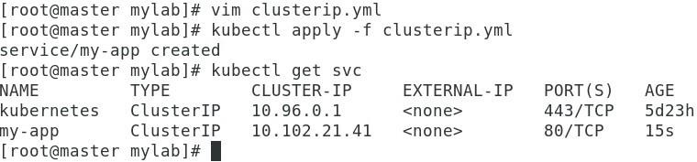

We have deployed the YAML file for both the replica set and the service resource.

Task 3: Verify the service using Kubectl command
- Run the command below to verify the service resource is applied and working properly.

kubectl get svc

- You will see a service named “my-app” where the type is mentioned as “ClusterIP” and the port protocol is mapped as declared. In order to get more details about the deployed service, run the describe command and notice the output.

kubectl describe service my-app

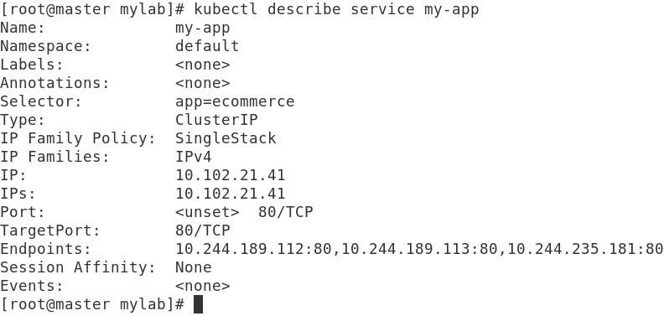
- Here, we can see that the labels mentioned in the deployment are mapped with the service which means the service is independent of the pod lifecycle and only works with respect to the deployment labels and replicas.

Also, by checking the endpoints field, we can confirm that the endpoints are nothing but the private ip addresses of the deployment pods which we launched earlier.
Apart from this, ClusterIP can also be used for assigning user-defined IP addresses to the pods and performing networking. Also, by using DNS services we can eliminate usage of IP addresses and call the services by domain names itself.
- You can verify the application
kubectl get svc curl <clusterIP>:80

Task 4 : How to delete the service?
By running the command below, we can delete the ClusterIP service. After performing this
action, the service will no longer serve as a networking component and no load balancing will take place for the mentioned endpoints.
kubectl delete svc my-app

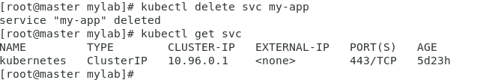
Completion and Conclusion
- You have successfully created a ClusterIP service in Kubernetes.
- You have successfully described the created resources and verified the applied resources are working.
- You have deleted the configured service and come across a few use cases of the same service.

End Lab
- You have successfully completed the lab.
- Once you have completed the steps, delete the resources.

Lab Details
- This lab walks you through the steps to understand and conﬁgure service networking with NodePort type
- You will use terminal.

Introduction

What are services in Kubernetes?
Services in Kubernetes allow us to implement a logical set of networking rules. Kubernetes internally allocates unique IP addresses to each pod and by deﬁning services, we can control the communication with the pods.
As pods are volatile and pods are created and destroyed multiple times to match the desired state, a pod becomes a non-permanent resource.
Kubernetes services provide abstraction over the underlying pods and set networking policies from which pods can communicate with each other and the application can be exposed to the end users.
The set of pods to route the traﬃc is managed through unique selectors. For example, pods having label frontend and backend respectively will have internal network communication by the service resource.
Generally, there are 3 types of service resources in Kubernetes: Cluster IP
NodePort Load Balancer
In this lab, we will look into the NodePort service with hands-on demo examples.

What is NodePort?
As we already know pod networking is majorly deﬁned by the service resource, NodePort provides the capability to expose the cluster to a port or set of ports for external access.
This service allows us to open speciﬁc ports of the mentioned nodes from where the
external user can access the underlying application running on the pod.
So, rather than connecting to the ephemeral pods on a speciﬁc IP address, the NodePort

service created an abstraction and provided a single point of access to the end user. On the other hand, it equally distributes traﬃc on the running pods by using the selector to detect the label and route the request.
So, after exposing the port from the host node, one can share the combination of the host IP address and the exposed port as a proxy to access the service running inside a pod of that node.
The default port range to expose from the node is 30000 to 32767. If the port is not deﬁned in the manifest while creating the service, Kubernetes will automatically assign unused and available ports from the mentioned range and bind the same to the NodePort.
Now let’s implement the NodePort service and understand the concept in detail.

Task Details
- Launching Lab Environment.
- SSH through the Whiz terminal
- Create the YML declarative ﬁle for the NodePort resource
- Verify the service using Kubectl command
- Delete the service

Lab Steps:

Lab Steps

Task 1: Launching Lab Environment
- Launch the lab environment by opening the Master machine.
- Open the terminal.

Task 2: Create the YML declarative ﬁle for NodePort resource
In this step, we will create the manifest ﬁle for NodePort service
Here, we have to mention 2 types of ports to route the traﬃc to the application running inside the pod. One is the port to be exposed from the node(can be picked from the default range mentioned above). The other port is the actual application port. For example: for a web server running inside the pod, the target port would be 80.
Using YAML approach
- Create a YAML ﬁle for the deployment of sample nginx pod using the command below:

vim deploy.yml

- Copy the below code into the YML ﬁle which will create a deployment of nginx server and by
default we will serve the content from port 80.
apiVersion: apps/v1 kind: Deployment metadata:
labels:
app: nginx
name: nginx-deployment spec:
replicas: 2
selector:
matchLabels:
app: nginx
template:
metadata:
labels:
app: nginx
spec:
containers:
- name: nginx
image: quay.io/gauravkumar9130/mywebapp

- The next step is to apply the YML ﬁle to launch the deployment using the command
below:

kubectl apply -f deploy.yml
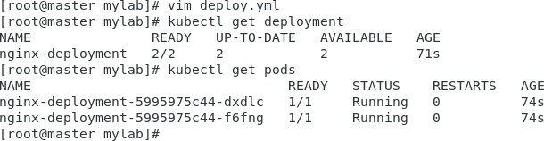

- Now comes the part to create the service and deﬁne the networking rule using which we will expose the nginx pod to the public world. Create a YML ﬁle using the command below:

vim nodeport.yml

- Now pass the below sample yml code. Here, apiVersion is v1 which means this resource
is included and maintained under the mentioned version of the Kubernetes API. Also, the keyword kind suggests the type of resource which is service in this scenario. We will use label selectors for the service to detect the apps running on the same hierarchy and eventually, it will distribute traﬃc equally based on the nodes.

apiVersion: v1 kind: Service metadata:
name: my-service
labels:
app: nginx spec:
selector:
app: nginx
type: NodePort
ports:
- nodePort: 31000
port: 80
targetPort: 80

- The next step is to apply this yml ﬁle to create the service as declared.

kubectl apply -f nodeport.yml

Till now, we have launched nginx server and created NodePort service which will expose the port number 31000 from the host node and bind the same to the target port 80 which is the default port for nginx.

Task 3: Verify the service using Kubectl command
- Let’s verify the deployed resources with kubectl commands. First, we will check the deployments and verify the running status of the pods.

kubectl get pods

- After verifying 2 replicas of nginx are running, run the below command to check whether the NodePort service is applied or not:

kubectl get svc

Here the port mapping states that port number 31000 from the host is linked with the port 80 of the pods having the label mentioned in the declarative ﬁle.
Now pick the node and copy the same in ip_address:31000 format and run it in the new browser window. The webpage will be displayed.
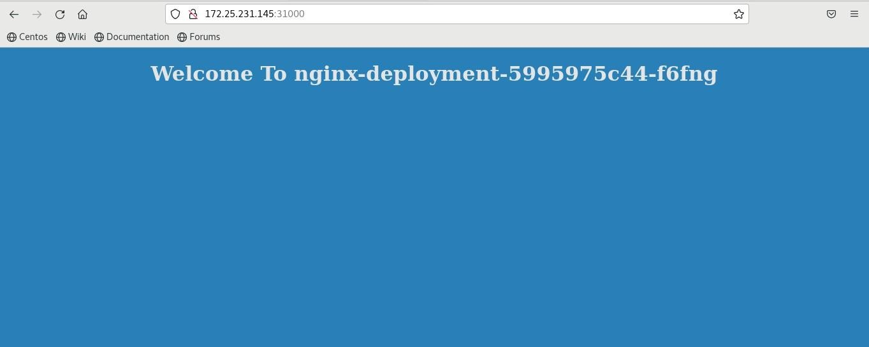

Hence, we can verify the cluster is exposed to the port and it is serving the content from the underlying pods. Besides, the service will provide load-balancing features and equally divert the requests to the replicas of the pods.

Task 5: How to delete the service?
1. This will delete the service resource and the exposed service will be stopped. Afterward, the request hit to the host from the node port will not be routed to the nginx pod.
kubectl delete svc my-service

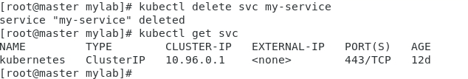

Completion and Conclusion
- You have successfully created a NodePort service resource in the Kubernetes.
- You have successfully exposed the Nginx-app service to public requests.
- You have deleted the conﬁgured service and detached the exposed application.

End Lab
- You have successfully completed the lab.
- Once you have completed the steps, delete the resources.

Lab Details
- This lab walks you through the steps to understand and configure service networking with LoadBalancer type
- You will using terminal.

Introduction

What is a Load Balancer service in Kubernetes?
Load balancer is yet another service resource in Kubernetes which allows us to perform networking on the Cluster.
Consider a general scenario of a multi-node cluster where each node is serving the same application inside the labeled pod. To expose the application to the end users, we can use the NodePort service. But each node will have a separate IP address and we have to explicitly share the IP port combination to the users for them to use the application. With this, we disclose the original IP of the node that is serving the application and it increases potential threat to the application as the endpoint is directly shared.
Also, in a situation of node failure, the end clients won’t be able to access the application as the given node is no longer reachable.
Hence, we need a service that runs on top of all underlying nodes and works as a proxy service between the clients and the application servers. Here we use the LoadBalancer service in Kubernetes.
We can attach external, cloud provider LoadBalancers to the existing clusters too. Also, this proxy service will equally distribute traffic to the underlying nodes and provide a LoadBalancing service.
In case the application is running on the cloud, by mentioning the LoadBalancer type service, it automatically provisions a load balancer and returns a public ip to share with the users.

Task Details
- Launching Lab Environment.
- Using the terminal.
- Create the YML declarative file for the LoadBalancer resource

- Verify the service using Kubectl command
- Delete the service

Lab Steps:

Lab Steps

Task 1: Launching Lab Environment
- Launch the lab environment by opening Master machine.
- Open the terminal.

Task 2: Create the YML declarative file for LoadBalancer resource
In this step, we will create the manifest file for the LoadBalancer service
Here, we have to mention 2 types of ports to route the traffic to the application running inside the pod. One is the port to be exposed from the node. The other port is the actual application port. For example: for a web server running inside thepod, the target port would be 80.

Using YAML approach
- Create a YAML file for the deployment of a sample nginx pod using the command below:

vim deploy.yml

- Copy the below code into the YML file which will create a deployment of the nginx server and by default we will serve the content from port 80.

apiVersion: apps/v1 kind: Deployment metadata:
labels:
app: nginx
name: app-deployment spec:
replicas: 2
selector:
matchLabels:
app: nginx
template:
metadata:
labels:
app: nginx
spec:
containers:
- image: quay.io/gauravkumar9130/mywebapp
name: nginx

- The next step is to apply the YML file to launch the deployment using the command
below:

kubectl apply -f deploy.yml

- Now comes the part to create the service and define the networking rule using which we will expose the nginx pod to the public world. Create a YML file using the command below:

vim loadbalancer.yml

- Now pass the below sample yml code. Here, apiVersion is v1 which means this resource is included and maintained under the mentioned version of the Kubernetes API. Also, the keyword kind suggests the type of resource which is service in this scenario. We will use label selectors for the service to detect the apps running on the same hierarchy and eventually, it will distribute traffic equally based on the nodes.
apiVersion: v1 kind: Service metadata:
name: my-app-service
labels:
app: nginx spec:
selector:
app: nginx
type: LoadBalancer
ports:
- port: 80
targetPort: 80

- The next step is to apply this yml file to create the service as declared.

kubectl apply -f loadbalancer.yml

Till now, we have launched the nginx server and created a LoadBalancer service, and configured Kubernetes to expose the Nginx service to the external world. This allows external users to access the Nginx application through the assigned external IP.

Task 3: Verify the service using Kubectl command
- Let’s verify the deployed resources with kubectl commands. First, we will check the deployments and verify the running status of the pods.

kubectl get pods

- After verifying 2 replicas of nginx are running, run the below command to check whether the LoadBalancer service is applied or not:

kubectl get svc
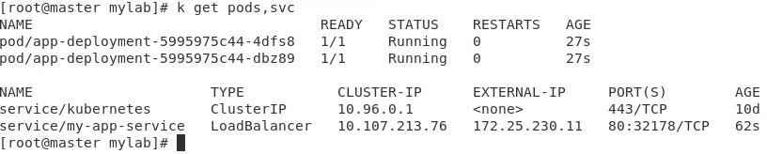
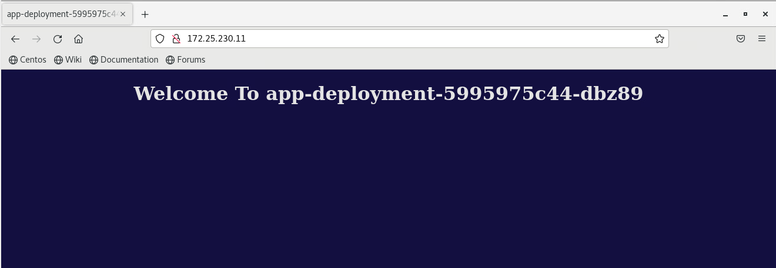

Here the port mapping states that port number 32178 from the host is linked with the port 80 of the pods having the label mentioned in the declarative file.
Now pick the external ip and run it in the new browser window. The nginx-app default webpage will be displayed.
Hence, we can verify the cluster is exposed to the port and it is serving the content from the underlying pods. Besides, the service will provide load-balancing features and equally divert the requests to the replicas of the pods.

Task 4: How to delete the service?
1. This will delete the service resource and the exposed service will be stopped. Afterward, the request hit to the host from the port will not be routed to the nginx pod.

kubectl delete svc my-service

kubectl delete deploy app-deployment

Completion and Conclusion
- You have successfully created a LoadBalancer service resource.
- You have successfully exposed the nginx-based app to external-IP.
- You have deleted the configured service and the exposed application.

End Lab
- You have successfully completed the lab.
- Once you have completed the steps, delete the resources.

